How to Get HandBrake with FDK-AAC for Windows (V3)

Introduction: As you are likely aware, the FDK-AAC encoder was removed from Handbrake (https://www.videohelp.com/software/HandBrake) from version 0.10.5 onwards, as it can no longer be publicly distributed due to GPL licensing issues (see: https://forum.handbrake.fr/viewtopic.php?f=33&t=34143).
The default AAC encoder Libav (https://www.videohelp.com/software/Libav) is lacking in quality compared to FDK (especially at lower bitrates) as its only a basic AAC encoder, however from version 1.2.0 onwards, HandBrake uses the FFmpeg AAC encoder which is better than Libav but still not as good as FDK (see this website for more info about AAC encoders: http://wiki.hydrogenaud.io/index.php?title=AAC_encoders). The Mac version of HandBrake uses Apple’s Core Audio AAC encoder, which is better than FDK but cannot be provided on Windows as its a proprietary library.

Fortunately, you can still compile HandBrake from source and enable FDK as an optional compile-time option, this guide will tell you how this can be done for the Windows version of HandBrake:
Warning: This process is not easy and is only recommended to more advanced users!
Note: This also works with VidCoder since it uses HandBrake as its encoding engine!
1. Fresh install Ubuntu (18.04.3 LTS is recommended due to a known set of packages and is easier for new users who want to attempt this process, later versions and other distros may work as well!), either on a PC via dual booting (or on a separate PC!), or on a Virtual Machine through software such as VirtualBox or VMware (recommended HDD space: 15-20GB with an allocated 2GB or more of RAM).
Ubuntu download: https://www.ubuntu.com/download/desktop
VirtualBox download: https://www.virtualbox.org/wiki/Downloads
See this guide if you need help installing Ubuntu in VirtualBox: https://linus.nci.nih.gov/bdge/installUbuntu.html
Alternatively, if you have the Windows 10 Creators update installed, you can complete this build process using the Windows Subsystem for Linux (WSL), however it is command line only and is only recommended for more advanced users, its also much slower due to the way it handles disk access! (See: https://www.howtogeek.com/249966/how-to-install-and-use-the-linux-bash-shell-on-windows-10/)
Obvious note: Don’t forget to press ‘enter’ after typing/pasting each terminal command to execute it!
2. Open a Terminal Window (Ctrl + Alt + T) and maximise it if you want to see all the text go by more clearly, you should start in your "Home" directory, which is: user@computer:~$ (it should already be in the “Home” directory by default).
3. Enter (or copy/paste the following commands into the terminal, WITHOUT quotes):

“sudo apt-get update” (this installs the latest updates in Ubuntu)

“sudo apt-get install automake autoconf autopoint build-essential cmake gcc git intltool libtool libtool-bin m4 make nasm ninja-build patch pkg-config python tar zlib1g-dev”

This will install/upgrade these required packages/dependencies to the latest versions (Some of these will likely already be installed).

“sudo apt-get install meson” (only enter this command if you are running Ubuntu 18.10)

If you are running Ubuntu 18.04 LTS, the meson package is too old, you therefore need to install a newer version provided by the Python Package Index with the following commands:

“sudo apt-get install python3-pip”
“sudo pip3 install meson”

You also need to install these additional dependencies required to build the MinGW-w64 toolchain: “sudo apt-get install bison bzip2 curl flex g++ gzip pax”

Note: You may be asked to enter your administrative password for Ubuntu after these commands, type it in, press enter, then press ‘y‘ and press enter again to confirm.
OPTIONAL: After the above commands, if you see some sort of message about packages no longer being required, enter:
“sudo apt autoremove” to delete them. These are usually old system kernels left over from software updates, and can/should be removed. The Ubuntu desktop uses System Settings->Details (the "gear" icon) to perform much the same function as Windows Update.
If you are running Ubuntu 16.04 LTS, the NASM version in the base repository is too old (2.11.08), so compile from source with the following command instead:
“curl -O https://www.nasm.us/pub/nasm/releasebuilds/2.13.02/nasm-2.13.02.tar.bz2
sudo tar -xf nasm-2.13.02.tar.bz2
cd nasm-2.13.02
sudo ./configure --prefix=/usr/local --enable-sections --enable-lto
sudo make -j$(nproc)
sudo make install
source ~/.bashrc
cd ..”
Then enter “cd” to return back to the "Home" directory.
See: https://handbrake.fr/docs/en/latest/developer/build-windows.html for more info.
4. Enter:

“git clone https://github.com/HandBrake/HandBrake.git && cd HandBrake”

This will download the entire HandBrake source code (repository) and place it in a directory called "HandBrake". Note that this is the NIGHTLY "master" code, not the latest "stable" release.

The Nightly builds are generally quite stable PROVIDED that you avoid cloning it during periods of intensive (i.e. multiple daily) developmental commits. (See: https://github.com/HandBrake/HandBrake/commits/master)
Check out the most recent release in the 1.3 series with the following commands:
“git tag --list”
“git tag --list | grep ^1\.3\.”
“git checkout refs/tags/$(git tag -l | grep -E '^1\.3\.[0-9]+$' | tail -n 1)”

OPTIONAL: If you want an older specific stable release of HandBrake, enter the following commands:
“cd HandBrake”
(this changes the directory to HandBrake)
“git tag”
(this lists the tags)
“git checkout tags/1.2.0”
(or whichever version you want from the list), this will pull that specific version of HandBrake from the repository you just downloaded, then enter “cd” to return back to the “Home” directory.
5. Depending on whether you’re using the 32 or 64-bit version of HandBrake in Windows, enter one of the following commands to build the MinGW-w64 toolchain where “username” is your Ubuntu username, feel free to use a different output path if desired:
32-bit (versions 1.0.7 or earlier only!):
“scripts/mingw-w64-build i686 /home/username/toolchains/”

64-bit:
“scripts/mingw-w64-build x86_64 /home/username/toolchains/”

Remember: all folder/file names are CASE-SENSITIVE! This will take around 40 minutes (possibly much longer depending on your PC setup!) to download the MinGW compiler and build it inside the "toolchains" directory (around 3-4GB).

6. When Step 5 is finished, you'll see a message very much like:
run the following command and add it to your shell startup script
(e.g., .bashrc or .bash_profile) to make persistent across sessions:
export PATH="/home/user/toolchains//x86_64/bin:${PATH}"
7. Use your mouse to copy the export PATH= ...etc... (whole line), and paste it into the Terminal. You might have to use the right-mouse context menu to copy/paste. This adds the MinGW compiler into the command search path.
8. Enter (optional):
32-bit (versions 1.0.7 or earlier only!):
“i686-w64-mingw32-gcc -v”
or
64-bit:
“x86_64-w64-mingw32-gcc -v”

to make sure Linux can find the compiler. If you see some "not installed" messages, go back to Step 6 and check carefully. There is no error message for adding a non-existent path string to ${PATH}.
9. Finally, enter:
“cd HandBrake”
(to change to the HandBrake directory), then enter one of the following commands to execute the build process:
32-bit (versions 1.0.7 or earlier only!):
“./configure --cross=i686-w64-mingw32 --enable-x265 --enable-qsv --enable-fdk-aac -- launch-jobs=$(nproc) --launch”

64-bit:
“./configure --cross=x86_64-w64-mingw32 --enable-fdk-aac --enable-qsv --enable-vce --enable-nvenc --launch-jobs=$(nproc) --launch”

10. After around 30 minutes or more (again depends on your PC setup) and mind-boggling walls of text, you should get a SUCCESS message. If you do have persistent problems with the build process, your best chance of success is to use a fresh Ubuntu install, use the File Manager to delete any existing “HandBrake” and “toolchains” directories you might have, only installing the packages from Step 3, and not go fiddling about too much with your Ubuntu setup.
11. Use the File Manager to copy the HandBrake/build/HandBrakeCLI.exe (no longer used by the HandBrake GUI in Windows from version 1.0.x) and HandBrake/build/libhb/hb.dll files to a location that Windows can access (e.g. through a shared folder if on a Virtual Machine).
See this guide for setting up a shared folder between Ubuntu guests and Windows host machines in VirtualBox (requires Guest Additions to be installed first): https://www.howtogeek.com/187703/how-to-access-folders-on-your-host-machine-from-an-ub...in-virtualbox/
12. Copy the file(s) from Step 11 into your HandBrake (or VidCoder) installation directory in Windows, overwriting the old ones. (Make sure that the version you built corresponds to the version you have installed, this also applies to which version of HandBrake that VidCoder is based on as well and whether its 32 or 64-bit!)
Note: You should backup your existing \Program Files\HandBrake directory, and definitely export your presets. There's a good chance a new version may wipe out your user presets.
13. Load up HandBrake or VidCoder in Windows and see if it works (do some test encodes/check the logs!), FDK-AAC should now be available to select as an audio codec in the dropdown list!
Note: The first time running it may result in missing UI elements or options. Exit & restart HandBrake, and all should be good. Sometimes, to fix crashing on startup, you also need to delete the "Users\(you)\AppData\Roaming\HandBrake" directory in your Windows drive, so that HandBrake can create a fresh configuration.

Warning: Doing this counts as a custom build of HandBrake and there is no support for it on their forum if you experience any issues, you are also NOT allowed to distribute custom builds of HandBrake with FDK enabled as its no longer GPL compatible.

Remember: Updating HandBrake (or VidCoder) through the GUI will overwrite the hb.dll file in their respective Windows installation directories, therefore losing FDK, you therefore need to repeat this process if you want to continue using newer versions of HandBrake or VidCoder with FDK-AAC!

Thanks to ‘WhatZit’ and ‘rwatt’ for original posts on the HandBrake forum: https://forum.handbrake.fr/viewtopic.php?f=11&t=34953

Thanks also to ‘CH_JC’ for an online Reddit guide focusing on building HandBrake in WSL: https://www.reddit.com/r/handbrake/comments/bnadr6/guide_how_to_custom_build_handbrake_eg_fdk_aac/

Thanks also to another online guide (originally in Japanese): https://translate.google.co.uk/translate?hl=en&sl=ja&u=https://www.apollomaniacs.com/ipod/howto_video_handbrake_build_hb.htm&prev=search

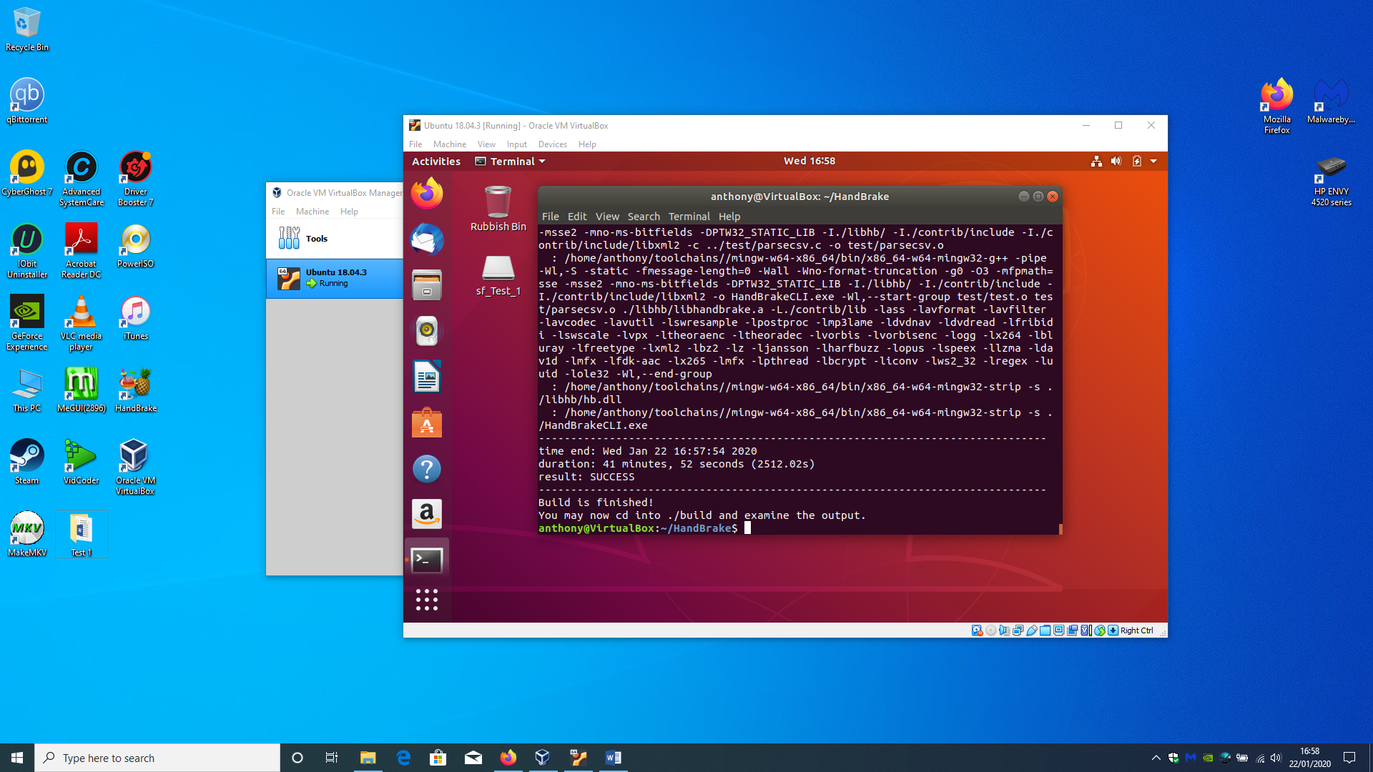
Example of successful HandBrake build completion in VirtualBox running Ubuntu 18.04.3 on Windows 10 host machine.

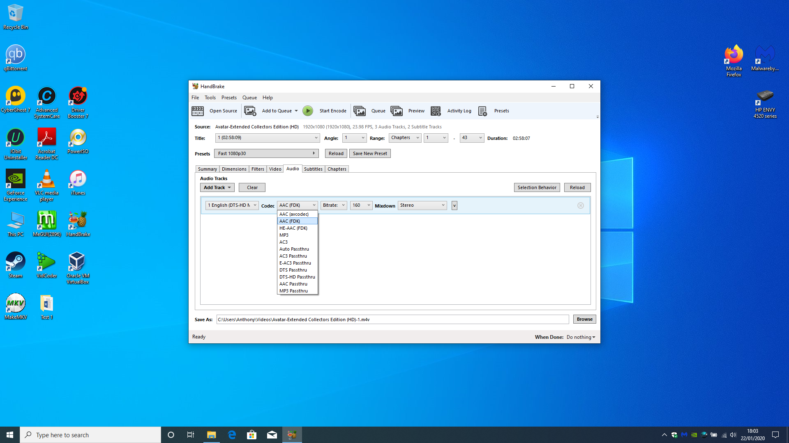FDK-AAC is now available to select as an audio codec in the HandBrake GUI (Windows 10 running version 1.3.1).

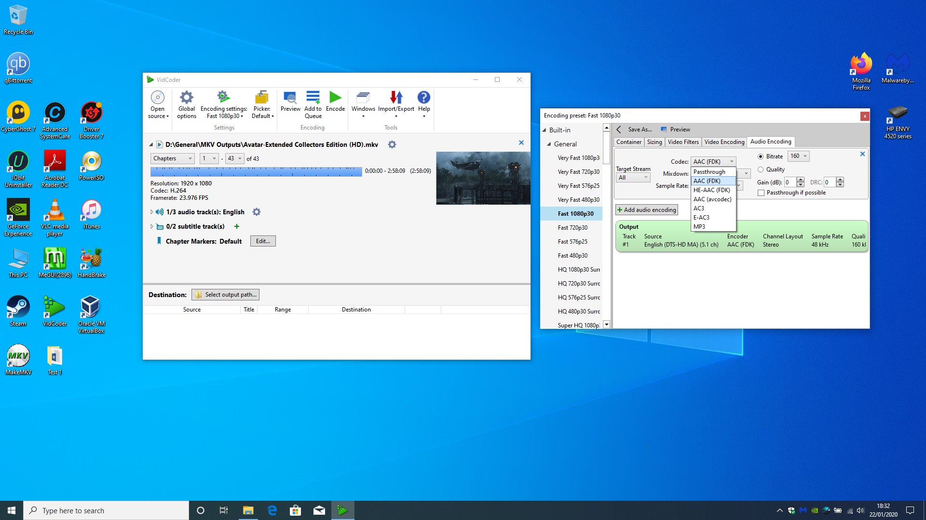
FDK-AAC is also available to select as an audio codec in the VidCoder GUI (Windows 10 running version 5.15 based on HandBrake 1.3.1).

